**EXPERIMENT NO.2**

AIM: To design the circuit of full adder.

IC USED: 7486(X-OR), 7408(AND), 7432(OR).

THEORY: A full adder is a logical circuit that performs an additional operation on three binary digits. The half adder produces a sum and a carry value which are both binary digits.

A full adder circuit has three inputs A,B and Cin and two outputs – S representing sum and Cout representing carry.

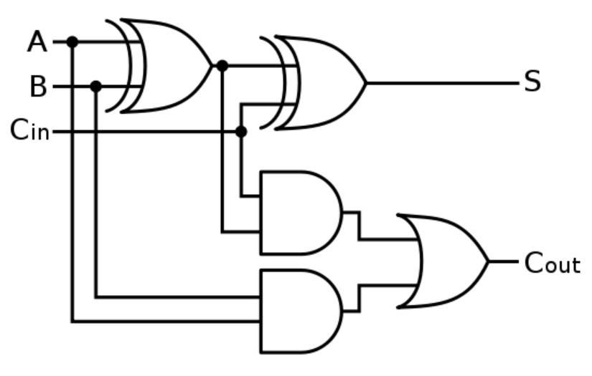

S = A xor B xor C

C = A.B +C(A xor B)

TRUTH TABLE:

| **A** | **B** | **Cin** | **S** | **Cout** |
| --- | --- | --- | --- | --- |
| 0 | 0 | 0 | 0 | 0 |
| 0 | 0 | 1 | 1 | 0 |
| 0 | 1 | 0 | 1 | 0 |
| 0 | 1 | 1 | 0 | 1 |
| 1 | 0 | 0 | 1 | 0 |
| 1 | 0 | 1 | 0 | 1 |
| 1 | 1 | 0 | 0 | 1 |
| 1 | 1 | 1 | 1 | 1 |

SCHEMATIC DIAGRAM:

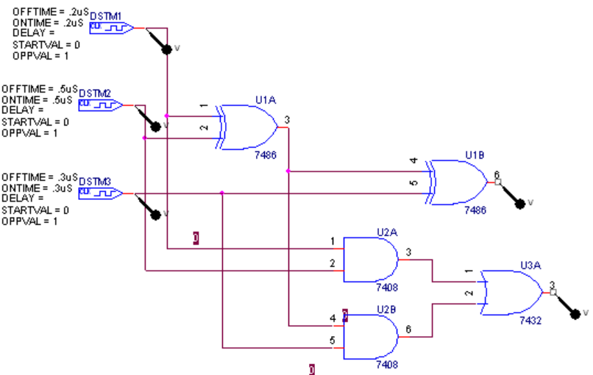

WAVEFORM:

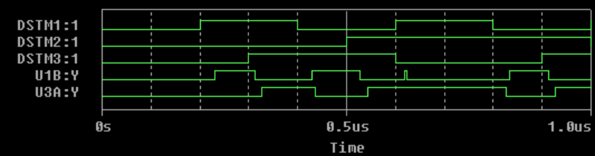

RESULT: The output waveform of half adder and Full Adder is verified.